Project Design Phase-II
Data Flow Diagram & User Stories

Date | 14 APRIL 2025
Team ID | SWTID1742640402
Project Name | MyRide
Maximum Marks | 4 Marks

1. Data Flow Diagram (DFD)
- External Entities:
  - Passenger
  - Driver
  - Payment Gateway
  - Admin
- Core Process: Cab Booking System
- Data Flows:
  - Passenger → Booking request → System
  - System → Driver assignment → Driver
  - System → Payment confirmation → Payment Gateway
- Processes:
  - Book Ride: Passenger submits pickup/destination → System validates → Generates fare estimate.
  - Assign Driver: System matches nearest driver → Sends notification.
  - Process Payment: System confirms payment → Updates booking status.
  - Track Ride: Real-time location sync between Driver ↔ Passenger.
- Data Stores:
  - User Database (Passenger/Driver profiles)
  - Booking Database (Ride details)

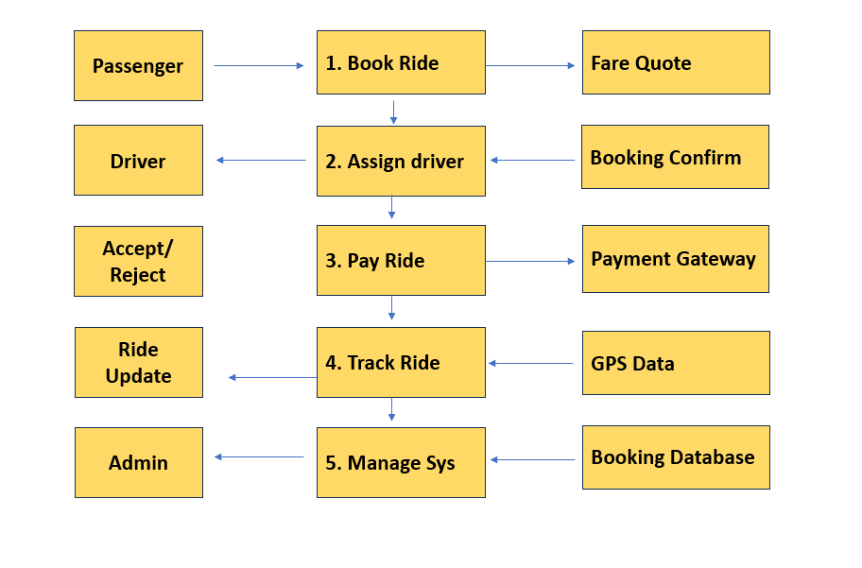
User Stories :
